TECHNICAL TEST PENTAMD

TESTS PERFORMED POKEMON PROJECT

**CREATE NEW POKEMON**

Method: POST

URL: <http://localhost:8080/pokemon/newpokemon>

BODY:

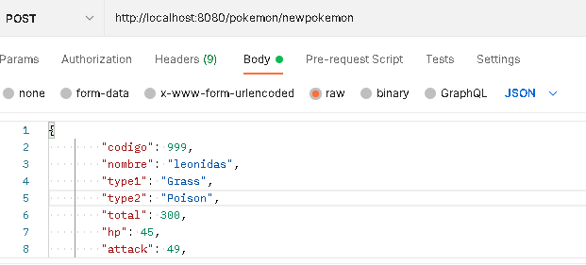

{

   "codigo": 999,

   "nombre": "leonidas",

   "type1": "Grass",

   "type2": "Poison",

   "total": 300,

   "hp": 45,

   "attack": 49,

   "defense": 49,

   "spattack": 65,

   "spdefense": 65,

   "speed": 45,

   "generation": 1,

   "legendary": **true**

}

EXAMPLE:

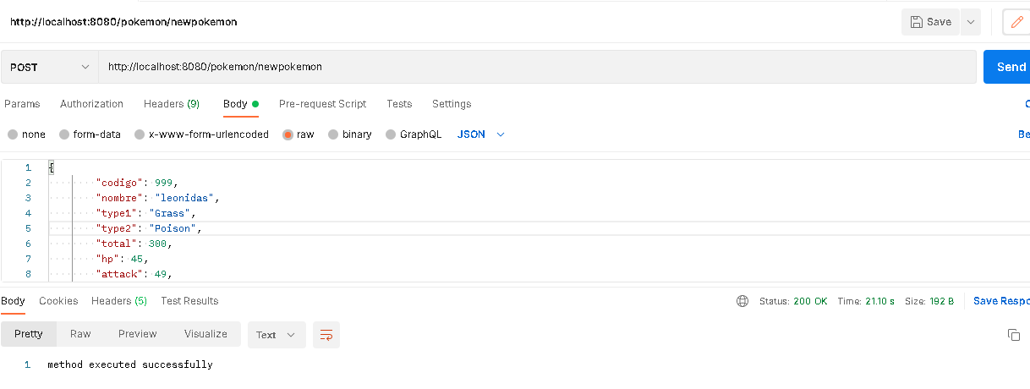

**LIST POKEMONs**

Method: GET

URL: <http://localhost:8080/pokemon/listpokemon>

BODY:

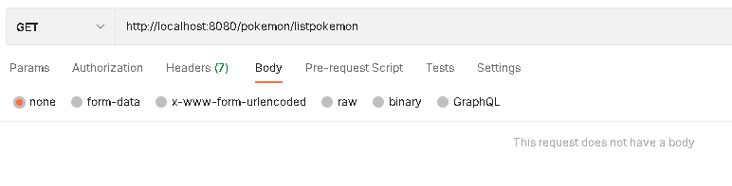

EXAMPLE:

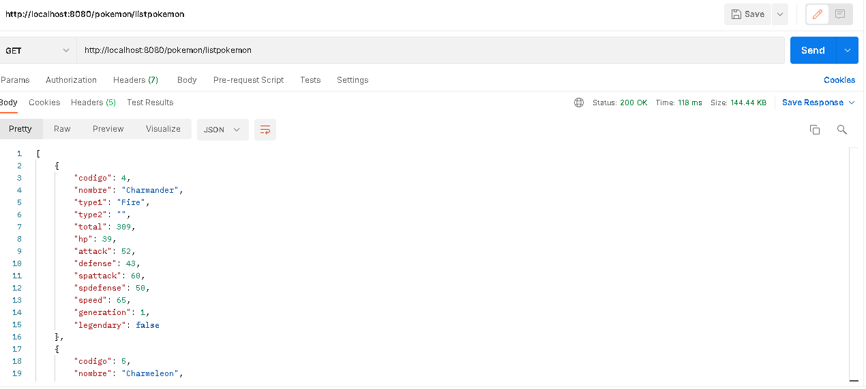

**CONSULT A POKEMON**

Method: GET

URL: <http://localhost:8080/pokemon/pokemon>

BODY:

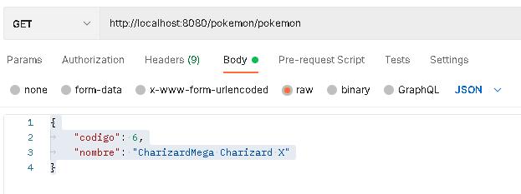

{

    "codigo": 6,

    "nombre": "CharizardMega Charizard X"

}

EXAMPLE:

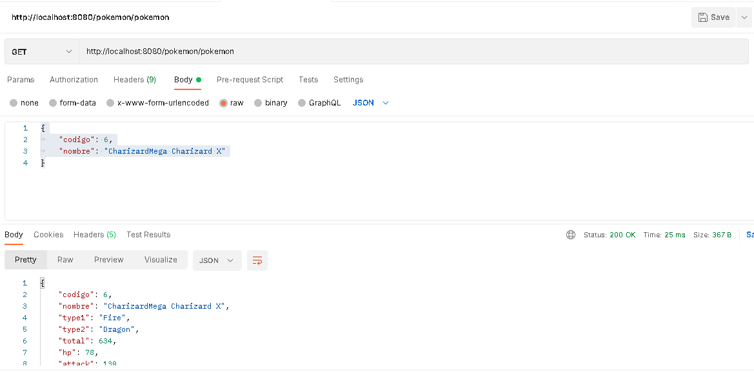

**DELETE POKEMON**

Method: DELETE

URL: <http://localhost:8080/pokemon/deletePokemon>

BODY:

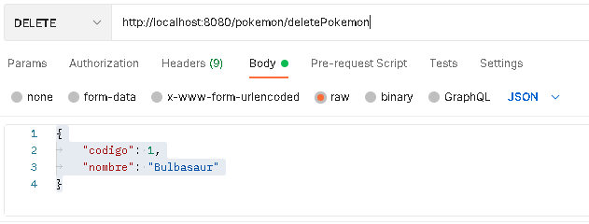

{

    "codigo": 1,

    "nombre": "Bulbasaur"

}

EXAMPLE:

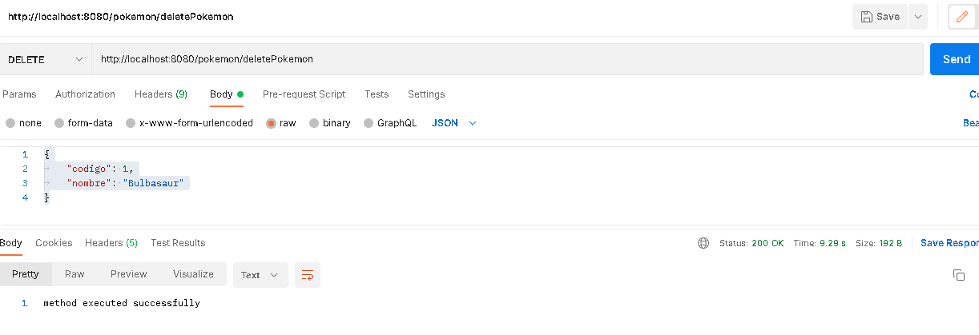

**UPDATE POKEMON**

Method: PUT

URL: <http://localhost:8080/pokemon/updatePokemon>

BODY:

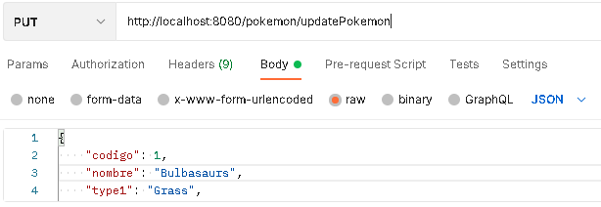

{

    "codigo": 1,

    "nombre": "Bulbasaurs",

    "type1": "Grass",

    "type2": "Poison",

    "total": 318,

    "hp": 45,

    "attack": 49,

    "defense": 49,

    "spattack": 65,

    "spdefense": 65,

    "speed": 45,

    "generation": 9,

    "legendary": **true**

    }

EXAMPLE:

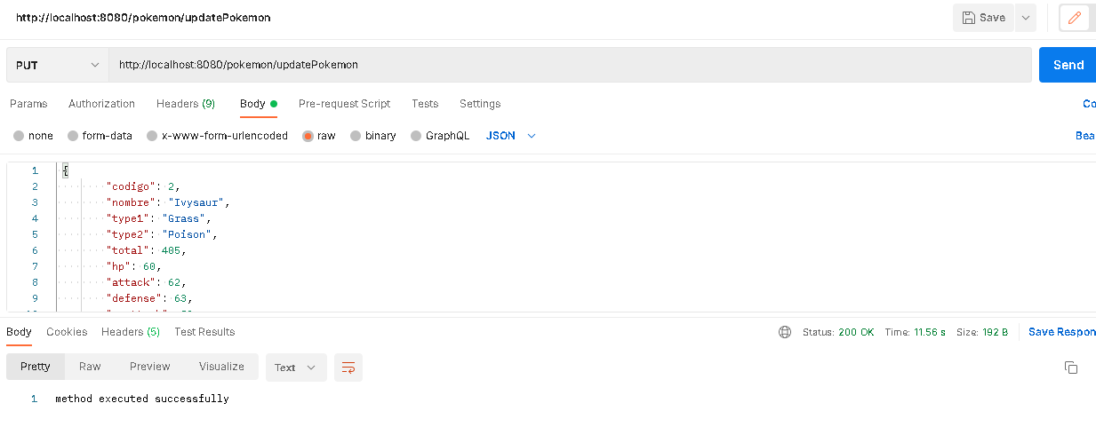

SWAGGER DOCUMENTATION

